Individual Music Lessons
In addition to our classroom practise, we also offer a range of peripatetic music lessons from professional music teachers, that you can read about below. These classes are delivered weekly on an individual or small group basis for 30 minutes, during lesson time. Please contact the school office for more information.

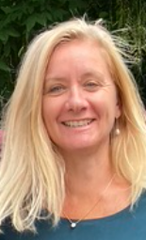
Hello! My name is Lisa, you may see me around school because I am one of the specialist musical instrument teachers at Hazeldown School. Throughout my teaching career, I have always taught instrumental lessons, on the trumpet, trombone, tenor horn, French horn, clarinet, recorder, and piano. I always strive to enrich the children I teach.
I have been a teacher for nearly 30 years, teaching in the UK and abroad too. I have taught in primary schools as a classroom teacher, head of year, and more recently as a full-time music teacher. I currently teach the whole class instrumental lessons in KS2 at Hazeldown as well as my private instrument lessons.

In my spare time, I enjoy walking, skiing, and cooking. I like to think of myself as a fun, happy and positive person.

At Hazeldown Primary School, I can offer instrumental lessons on the following instruments:
trumpet, trombone, tenor horn, French horn, clarinet, recorder, and piano.

My prices are:
20 minutes - £11 individual lessons
20 minutes - £5:50 shared lessons - depending upon demand.

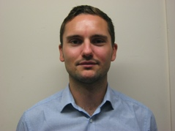
Hello, I am Max! I am the guitar tutor at Hazeldown. I am an experienced guitarist and tutor with nearly 15 years’ experience of teaching. I have been helping children at Hazeldown to develop their skills on the guitar and their passion for music for over ten years. I am also a busy musician and have performed in many successful local bands since my teenage years.

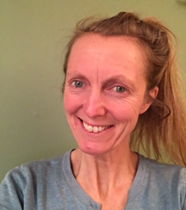
Hi, my name is Becky and I offer violin and piano lessons at Hazeldown on a Tuesday. I graduated from the Royal Academy of Music in 1991, and ever since then, in addition to performing, recording, and writing music; I have taught violin, viola, and piano/keyboard lessons. I really enjoy working with children and like to make the lessons fun and friendly whilst encouraging good progress. Some children just love to play and progress at their own speed, whilst others like to work their way up through the grades and I support both choices. To be a good musician takes time and practise but should always be a pleasure!

My prices £9 for 25 mins shared (beginners only in the first term or two), £11.30 for 20 minutes and £17 for 30 minutes.

