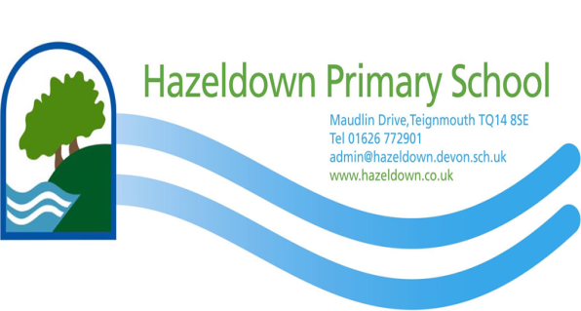

PSHE & RSHE Policy
(Intent & Implementation)

This policy was adopted by the School Governing Body on

18th October 2023

Review Date: October 2024

Intent (The ‘why’)

“ It is our choices that show what we truly are, far more than our abilities” (J. K. Rowling)

Rationale
Personal, social, health and economic (PSHE) education equips pupils with a sound understanding of risk and with the knowledge and skills necessary to make safe and informed decisions.

At Hazeldown, PSHE is at the centre of all that we do. It promotes the spiritual, moral, cultural, mental and physical development of pupils both when they are at school and in society; it prepares them for the opportunities, responsibilities and experiences of later life. Children will discuss strategies for dealing with different situations in a respectful, familiar setting. They will practise role playing scenarios and share ideas for solving problems. Children will be given opportunities to support one another and will know who or where to go to for advice.

Through our PSHE curriculum, children will be provided with key skills, attributes and knowledge which can be developed and applied. This will instil in the children the benefits of positive behaviour, good mental health and wellbeing, resilience and achievement. Our curriculum will help children to stay safe online, develop healthy and safe relationships and make sense of media messages. It will equip children with the skills and knowledge needed to challenge extreme views and be able to negotiate and assert themselves, now and in the future.

Our PSHE education includes statutory relationships and health education and non-statutory sex education (jointly known as RSHE), as recommended by the DfE, and provides a framework though which key skills, attributes and knowledge can be developed and applied. This will all be age appropriate and will build knowledge and life skills over time in a way that prepares pupils for issues they will soon face. Within sex education, sexual relationships are discussed in the context of a stable, loving relationship.

Through our curriculum, our school environment and our school ethos, we promote pupils’ self-esteem and emotional well-being and help them to form and maintain worthwhile and satisfying relationships based on respect for themselves and for others, at home, at school, at work and in the community.

Aims:
Our PSHE/RSHE curriculum aims to:
- give pupils the knowledge and develop the self-esteem, confidence and self-awareness to make informed choices and decisions;
- encourage and support the development of social skills and social awareness;
- enable pupils to make sense of their own personal and social experiences;
- promote responsible attitudes towards the maintenance of good physical and mental health, supported by a safe and healthy lifestyle;
- enable effective interpersonal relationships and develop a caring attitude towards others;
- enable children to develop their own appropriate sense of moral responsibilities with due respect for others and with an understanding of different forms of family life;
- encourage a caring attitude towards, and responsibility for, the environment;
- help our pupils understand and manage their feelings, build resilience and be independent, curious problem solvers;
- help our pupils understand how society works and the laws, rights and responsibilities involved;
- help children understand and come to terms with their physical and emotional development as they grow into adults;
- encourage a sense of respect for their own and others’ feelings, decisions, right and bodies;
- allow children the opportunity to discuss freely, to explore attitudes and to develop the necessary skills to develop personal relationships;
- generate an atmosphere where questions about sexuality and reproduction can be treated without embarrassment;
- give children factual knowledge of reproduction and provide an acceptable vocabulary for parts of the body;
- explain the changes of puberty;
- enable children to understand the rights they have over their own bodies.

We know there is a proven link between pupils' health and wellbeing and their academic progress. Crucial skills and positive attitudes developed through a comprehensive PSHE/RSHE education are critical to ensuring children are effective learners.

Implementation

Curriculum Organisation
All pupils are entitled to a progressive and comprehensive PSHE programme which covers National Curriculum requirements and which will be age appropriate, building on knowledge and skills over time.

Our pupils follow the SCARF programme of study, a comprehensive scheme of work for PSHE and wellbeing education. This has been created by the leading children’s charity, Coram Life Education, and follows a values-based and ‘Growth Mindset’ approach aimed at promoting positive behaviour, mental health, wellbeing, resilience and achievement. PSHE is also discretely taught through other curriculum areas and, where needed, through circle time and small group activities, as well as through whole school, team and class assemblies.

In Key Stage One and Key Stage Two, the SCARF programme splits the curriculum into six different half-termly topics: Me and my relationships; Valuing difference; Keeping myself safe; Rights and responsibilities; Being my best and Growing and changing. Children receive a one-hour session each week. An overview of SCARF can be found below. It covers all of the DfE's new statutory requirements for relationships education and health education, including both the statutory aspects of sex education that are taught in the statutory National Curriculum (science and health education) and the non-statutory aspects as outlined in our school’s medium term planning document (appendix 1).

Children in Year 6 also have the opportunity to take part in the Torbay and Devon Civic Award. This is entirely voluntary and aims to encourage citizenship amongst ten and eleven-year olds by encouraging them to make a difference in their communities and be prepared to take responsibility for change.

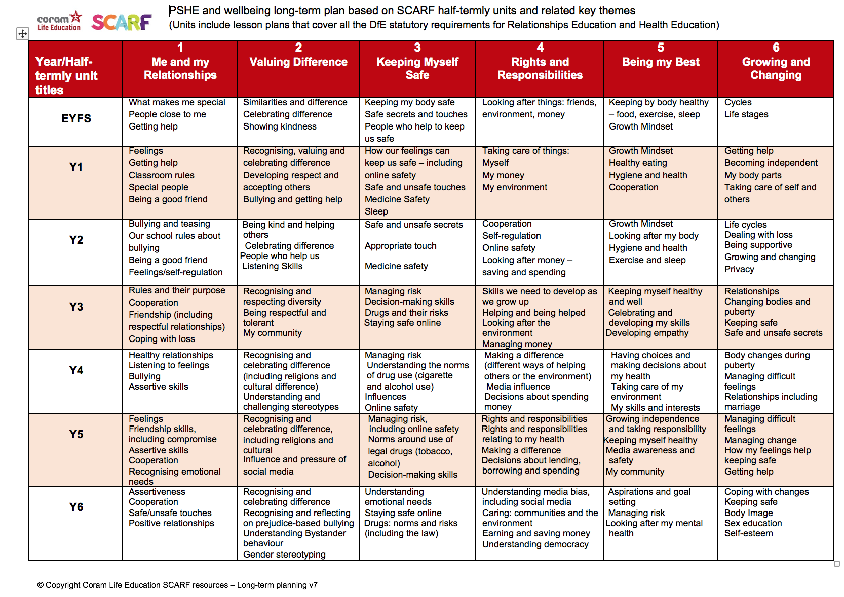

Teaching and Learning

What is being taught

The Early Years Foundation Stage (EYFS)

In the EYFS, RSHE education is about making connections; it’s strongly linked to child-led activities, including play. RSHE is taught through activities that are part of topics, as well as on an individual basis to develop personal skills such as dressing, feeding and toileting. Positive experiences are built through daily opportunities to share and enjoy a range of different activities. Children are given the opportunity to engage in social activities, as members of a small group or occasionally during whole-school activities.

KS1 and KS2
The SCARF programme divides the year into six themed units, as detailed above.

Children are encouraged to engage in activities that promote an understanding of themselves as growing and changing individuals, and as members of a wider community, based on their own first-hand experiences. These activities also encourage pupils to understand how their choices and behaviours can affect others. They are encouraged to play and learn alongside – then collaboratively with – their peers. They may use their personal and social skills to develop or extend these activities. Children are also given the opportunity to make choices about their health and environment and are encouraged to develop a caring attitude towards others.

Within National Curriculum science in Year 2, the children learn that animals, including humans, have offspring that grow into adults. They should be introduced to the concepts of reproduction and growth, but not how reproduction occurs. In Year 5, children are taught about the life cycles of humans and animals, including reproduction. They also learn about the changes that happen in humans from birth to old age. This includes learning what happens in puberty.

It is important that the transition phase before moving to secondary school supports pupils’ ongoing emotional and physical development effectively. The DfE recommends that all primary schools should have a sex education programme, tailored to the age and the physical and emotional maturity of the pupils. Within our non-statutory sex education that takes place in Year 6, children will learn about how a baby is conceived, whether through sexual intercourse or IVF. This information builds on content they have previously learnt in the programme about relationships, puberty changes and reproduction; it lays the foundations for their ongoing relationships and sex education in their secondary phase.

How RSHE is taught
Class teachers follow the suggested six half termly units provided by SCARF for each year. The lesson plans list the specific learning objectives for each lesson and provide support for how to teach the lessons; class teachers and our RSHE lead often discuss this on an informal basis.

RSHE lessons are taught throughout the year by class teachers in their timetabled RSHE lessons, in their usual classes and mixed sex groupings (sometimes teachers may make the decision to split their class into boys and girls for certain discussions). A range of interactive teaching methods are used, e.g. activity sheets, films, songs, online games, and drama techniques.

Through regular INSET training and support, all staff are equipped with the knowledge, skills and resources to deliver our RSHE education confidently. Teachers can access a range of teaching support resources within SCARF, including guidance documents and teacher training films.

To ensure children feel comfortable to learn about a range of topics we:
- provide a safe learning environment through the establishment of clear rules which are made explicit to the children and reinforced consistently;
- answer children’s questions factually and honestly in an age-appropriate way and respond to any disclosures following the school’s safeguarding procedures;
- provide anonymous question boxes in each class to allow children to write down any questions or worries they may have without drawing any attention to themselves;
- invite visiting speakers, such as the police and health workers, to contribute to the taught curriculum, reflecting our school’s values and ethos;
- support pupils in applying the skills they are learning in real life situations as they arise: e.g., resolving conflicts; working as part of a group on a project and sharing their thoughts on a school matter to a wider group;
- encourage children to take part in a range of practical activities to promote active citizenship, e.g., charity fundraising; the planning of special events at school; making class rules; school council meetings and by taking on roles of responsibility for themselves, for others and for the school;
- encourage year 6 pupils to participate in the Torbay and Devon Civic Award which aims to encourage citizenship amongst ten and eleven-year-olds and is routed in a deep belief that education should be broader and more futures-driven.

Parental concerns and withdrawal of students
Parents have the right to withdraw their children from the non-statutory components of sex education within RSHE (this refers to part of the lesson entitled Making Babies in the year 6 curriculum only). Parents do not have the right to request that their children be withdrawn from any of the relationships or health education or those aspects of sex education that are taught in the statutory National Curriculum (science and health education).

Parents are invited to view our resources and discuss any concerns with our staff.

Before granting a request to withdraw a child, the child’s teacher / PSHE subject leader will invite the parent to discuss the request with them to ensure their wishes are understood and to clarify the nature and purpose of the curriculum. The child’s teacher / PSHE subject leader will discuss with the parent the benefits of receiving this important education and any detrimental effects that withdrawal might have on their child. This could include any social and emotional effects of being excluded, as well as the likelihood of the child hearing their peers’ version of what was said in the classes, rather than what was directly said by the teacher (although the detrimental effects may be mitigated if the parent proposes to deliver sex education to their child at home instead). The school is responsible for ensuring that should a child be withdrawn, they receive appropriate, purposeful education during the period of withdrawal.

Parents should be given every opportunity to understand the purpose and content of relationships education and sex education. Good communication and opportunities for parents to understand and ask questions about our school’s approach help increase confidence in the curriculum.

It is statutory for our school to show parents examples of the resources we plan to use. We provide opportunities for parents to view examples through class/year group meetings either face to face or virtually. Ongoing communication with parents about what is planned to be taught and when, will be provided through letters home. We advise parents to view the resources in order to support them in carrying out their responsibilities relating to providing RSE at home. It is valuable for a child’s development to learn about their own family’s values in regard to relationships and sex alongside the information they receive at school.

Assessment and recording
All assessment in PSHE/RSHE will be in carried out in line with the National Curriculum and in accordance with the assessment policy, which is followed throughout the school.

Assessment in PSHE/RSHE is a continuous process and the individual teaching the subject should note individual pupils’ progress to provide guidance for future teaching and learning and for reporting at the end of the school year. Assessment grids are completed half termly for each class from Years One to Six.

Within lessons, class teachers provide an opportunity to elicit pupils’ prior understanding through completion of mind maps. These are added to, using a different coloured pen, to demonstrate developments in pupils’ learning.

The PSHE leader monitors teaching and progress in PSHE/RSHE through:
- informal discussions with teachers, teaching assistants and children;
- assessing pupils’ work and progress;
- observing lessons;
- participating in Learning Journal ‘book looks’.

Roles and responsibilities of the subject leader
The role of the PSHE subject leader within the school is to:
- ensure coverage, continuity and progression in planning;
- monitor and evaluate the effectiveness of PSHE/RSHE teaching and learning;
- support and guide the practice of teachers and support staff;
- update documentation where necessary;
- produce an action plan, which will support the School Improvement Plan;
- liaise and consult with outside agencies where appropriate;
- prepare and lead INSET CPD sessions;
- attend relevant CPD training, or arrange for their colleagues to attend;
- report to the governing board on developments within the subject.

Resources
All PSHE/RSHE resources are stored electronically as part of the SCARF programme and can be accessed by all teaching staff. Sufficient resources are available for all half-termly units, with the resources required identified by SCARF. Resources are updated when necessary and include an electronic book list, which can be accessed via links. Additional resources are acquired by the PSHE subject leader, when necessary.

Equal Opportunities:
All children have equal access to the PSHE/RSHE curriculum and their associated activities. All members of staff are responsible for ensuring that all children have access to the whole curriculum and make the greatest possible progress. Where appropriate, work will be adapted to meet children’s needs and matched to their knowledge, understanding and previous experience. If appropriate, extra support will be given. Higher attaining children will be given suitably challenging activities and questioning. Gender, race, cultural background and disabilities will be reflected positively in the teaching materials used.

Our school ensures that the relationships and sex education (RSE) elements of the RSHE education programme are relevant to all pupils, whatever their gender identity. All pupils learn together about all the changes that someone may experience as they go through puberty to help develop empathy and understanding and to reduce incidences of teasing or stigma. This will also ensure any child that identifies as transgender will have access to RSHE that is relevant to the puberty they are likely to experience.

Our school acknowledges different ethnic, religious and cultural attitudes, as well as recognising that pupils may come from a variety of family situations and home backgrounds. These different families are acknowledged through our teaching and the use of resources that promote diversity and inclusion in relationships education.

Research shows that, on average, about 4% of pupils will go on to define themselves as gay, lesbian, bisexual or pansexual (GLBP). It is possible that some pupils will also have GLBP parents/carers, brothers or sisters, other family members and/or friends. Our RSHE education acknowledges this through scenarios, in a sensitive, honest and balanced consideration of sexuality. This helps create a safe environment for all pupils and staff. The public sector equality duty, created under the Equality Act, requires schools and other public authorities to eliminate discrimination and to advance equality in its everyday business, in the design of its policies and curriculum. Schools have a legal responsibility for eliminating discrimination; to do this, schools are required to raise pupils’ awareness of diversity and promote respectful relationships with those who are different from them.

Monitoring
This policy is monitored through:
- regular ‘book looks’, where the quality of children’s work is explored;
- evaluation and analysis of any assessment evidence;
- learning walks and observations, where the quality of teaching and the implementation of planning is assessed;
- pupil conferencing and, where appropriate, questionnaires.

The policy will be monitored by Amanda Maguire, PSHE/RSHE subject leader, in consultation with Lee Goodenough, curriculum leader, and Stuart Ludford, Headteacher. The policy is reviewed by staff – and agreed by the governing body – annually.

Date: October 2023

Appendices

- SCARF medium-term planning overview by year group. Non-statutory aspects of sex education have been highlighted yellow. Please note, these are the only lessons parents are able to withdraw their children from.

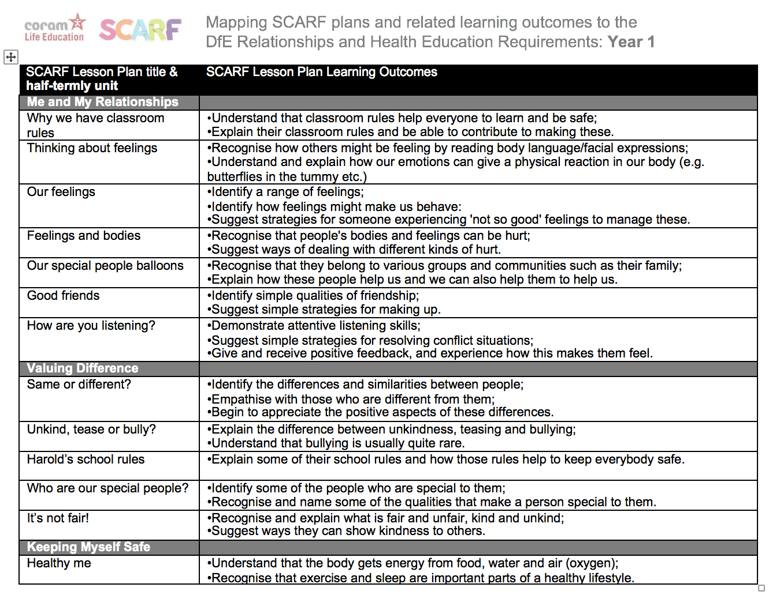
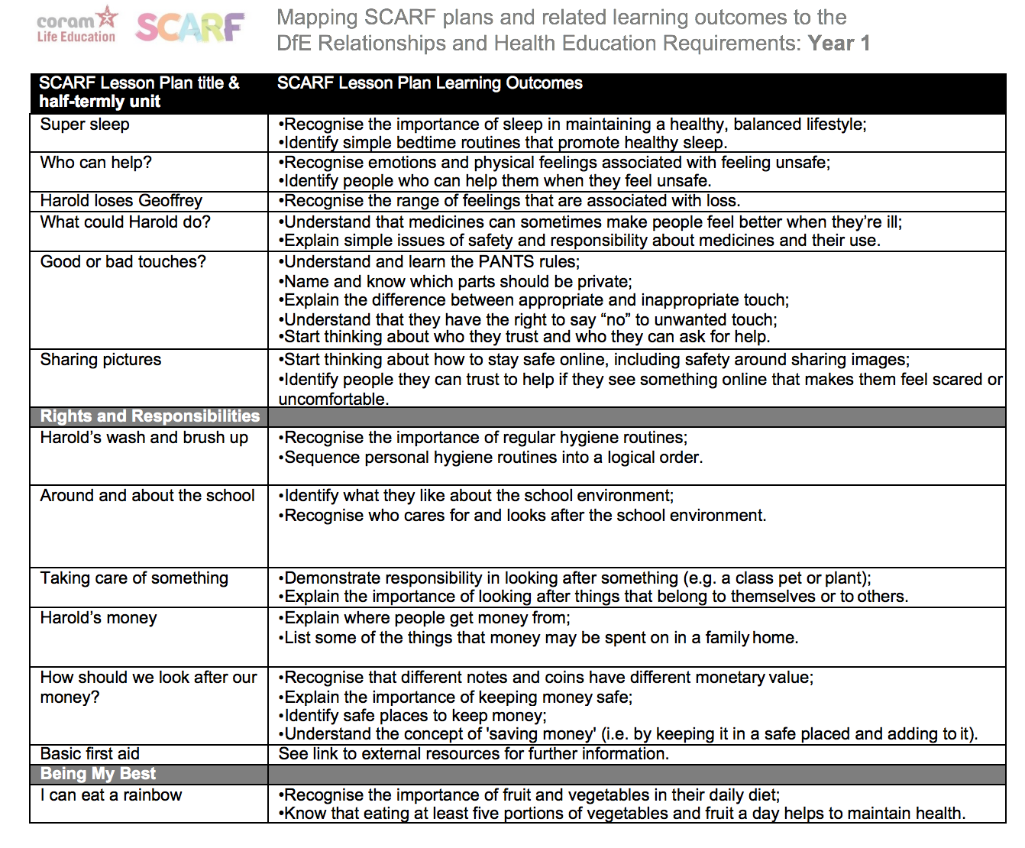

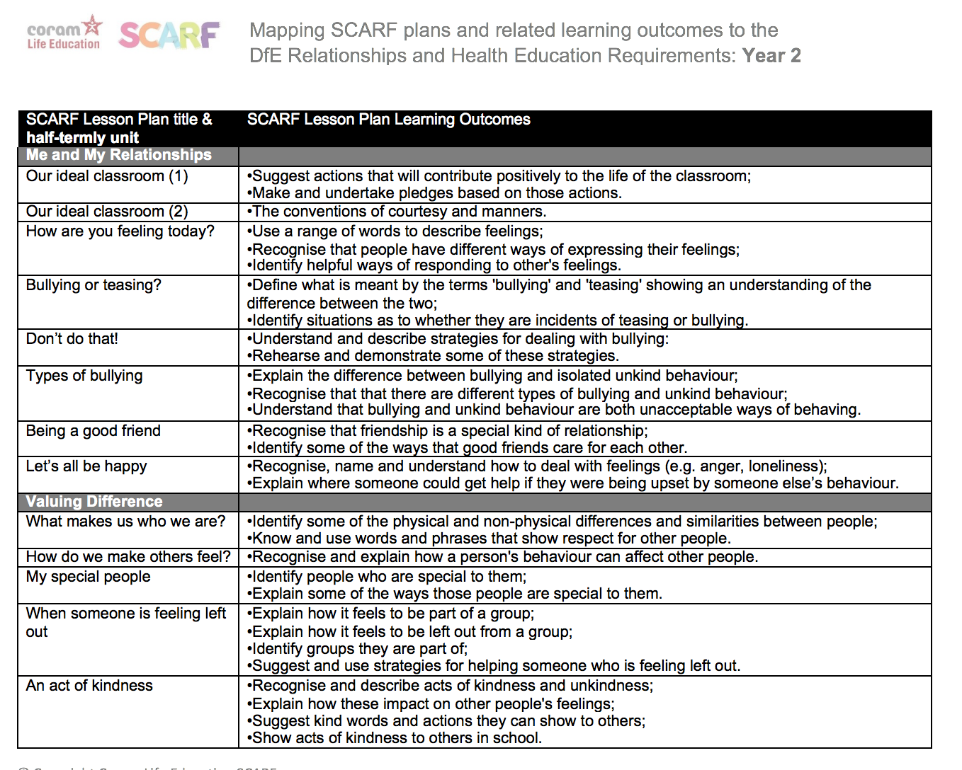
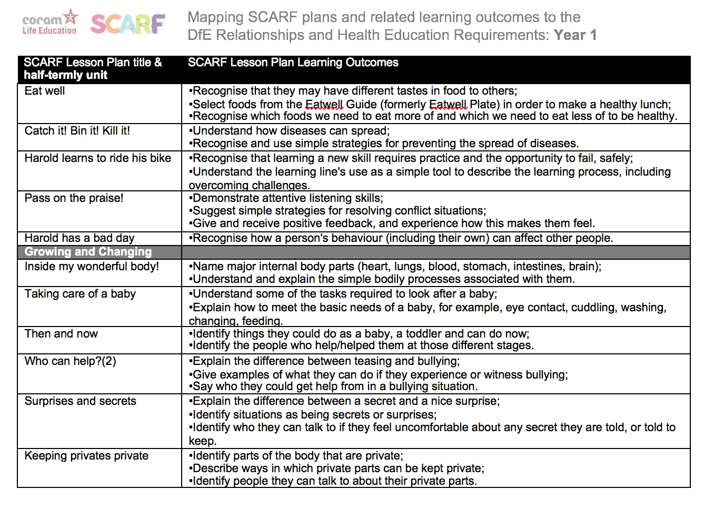
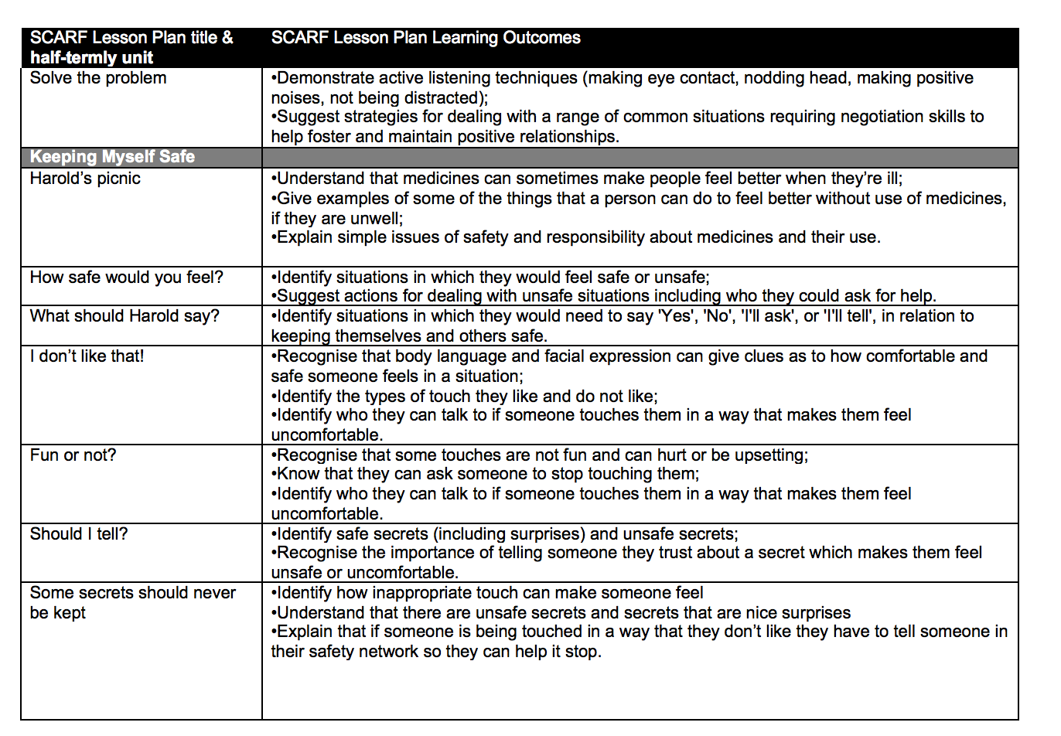
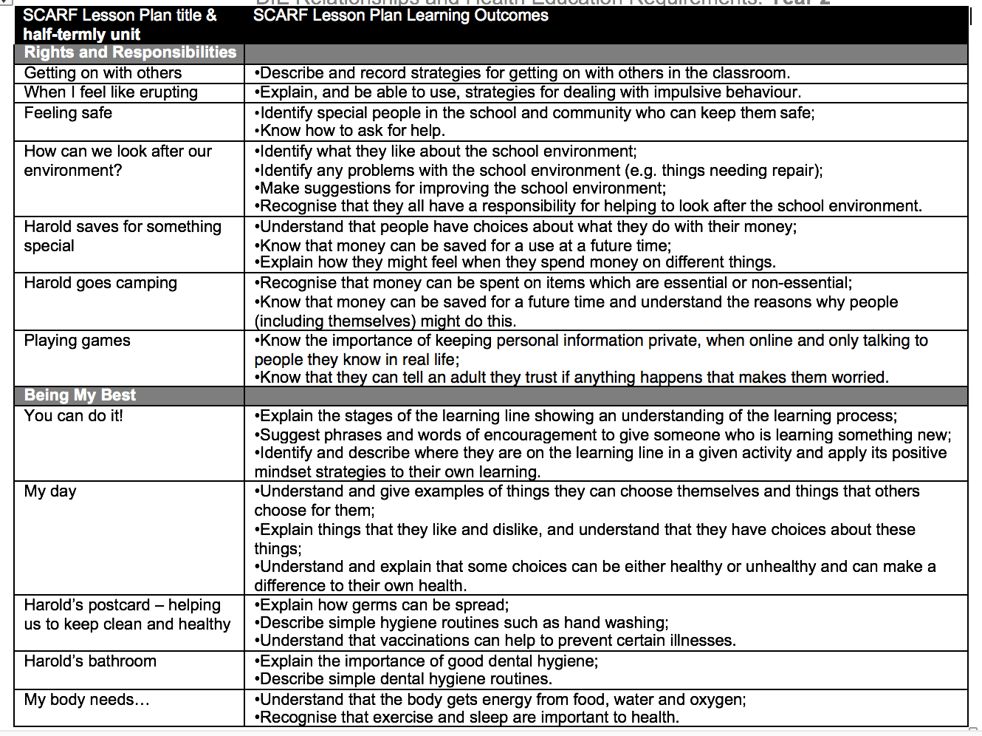

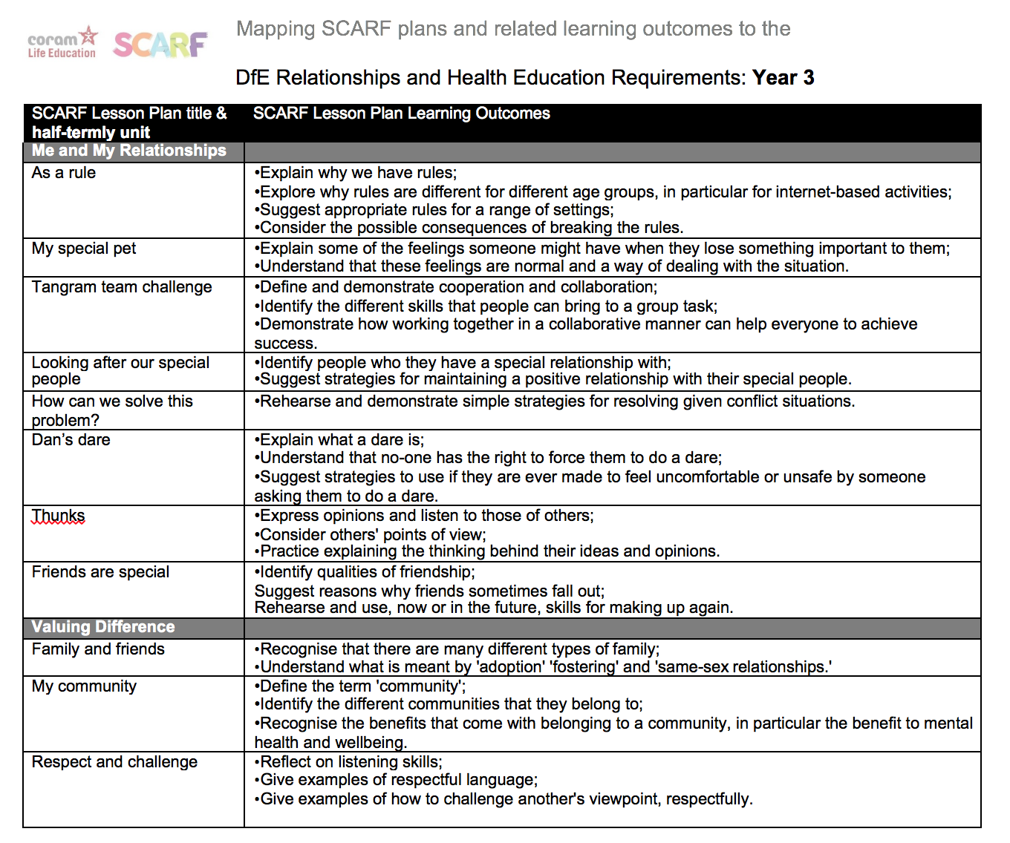
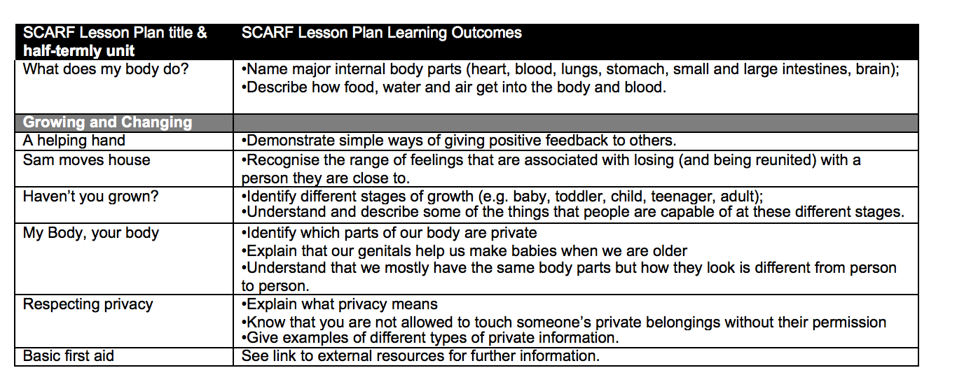
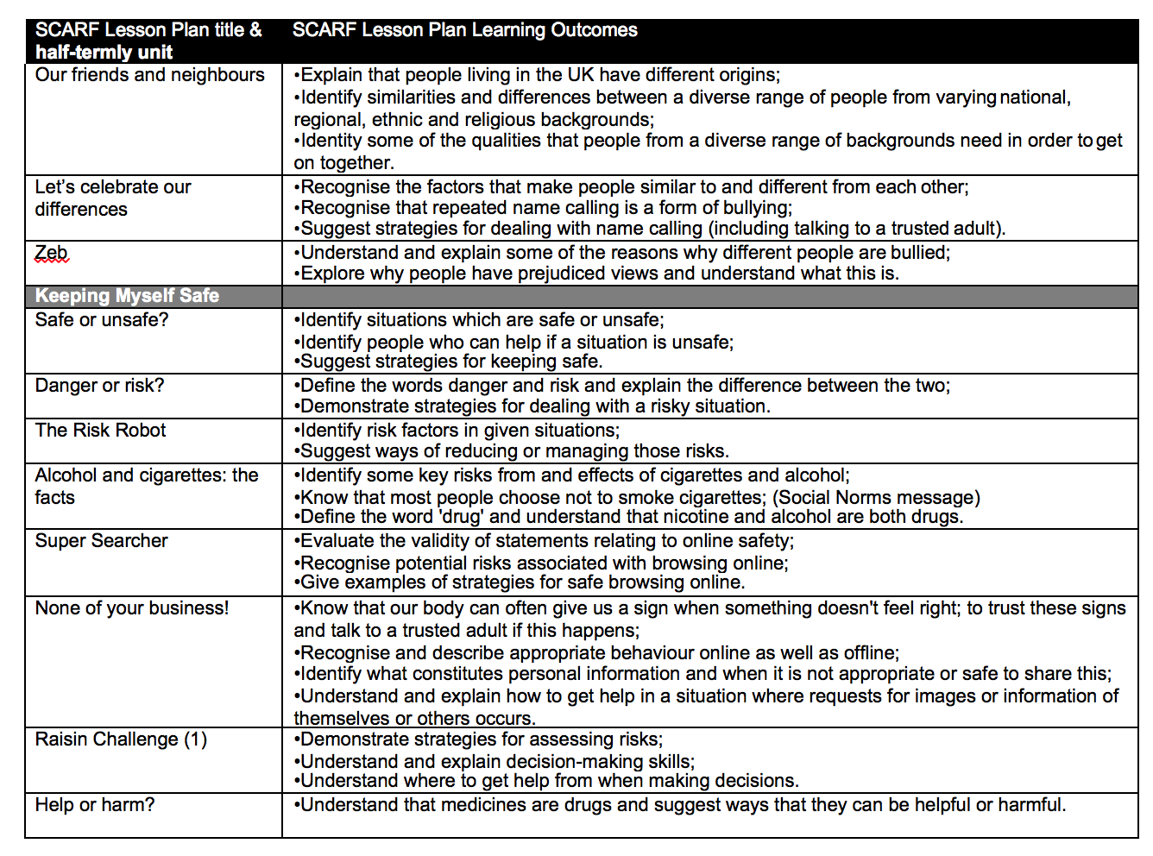
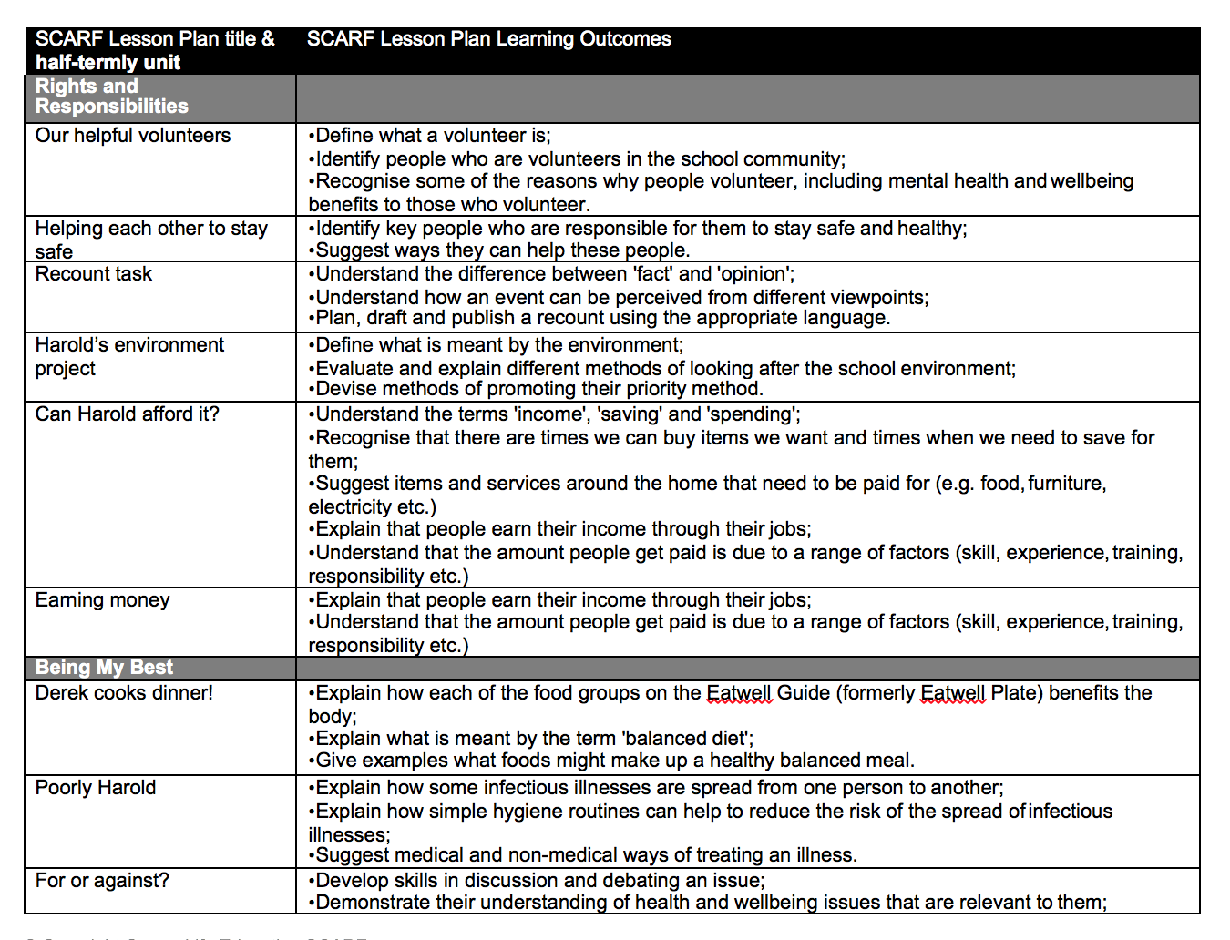
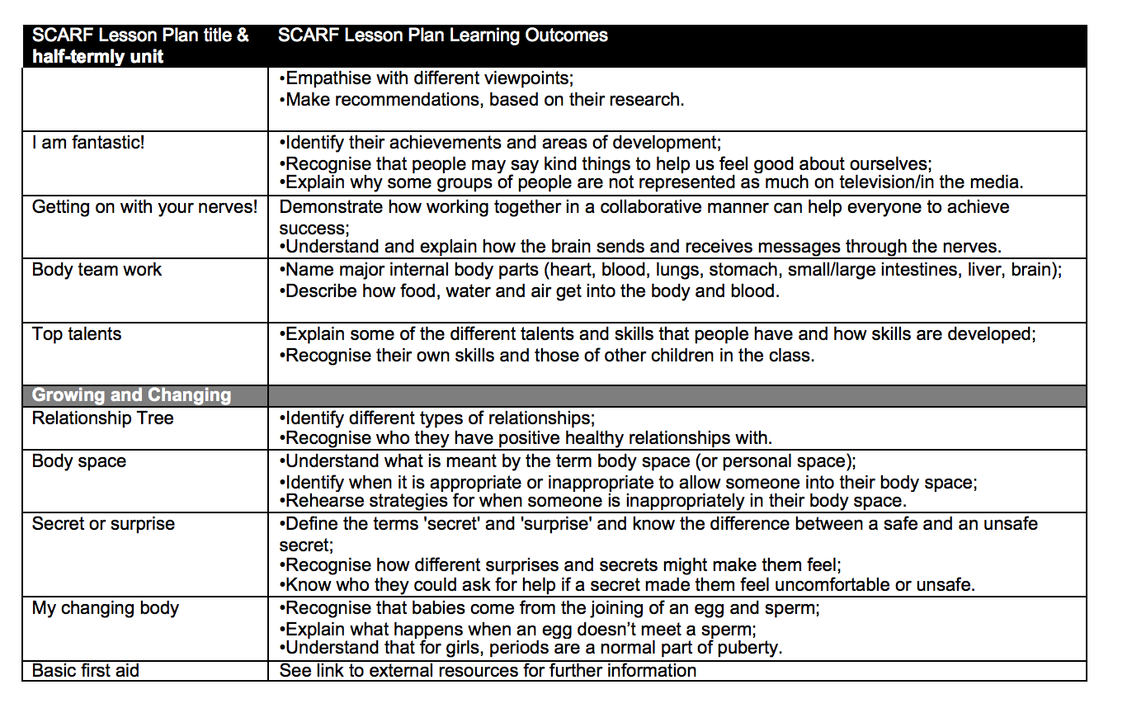
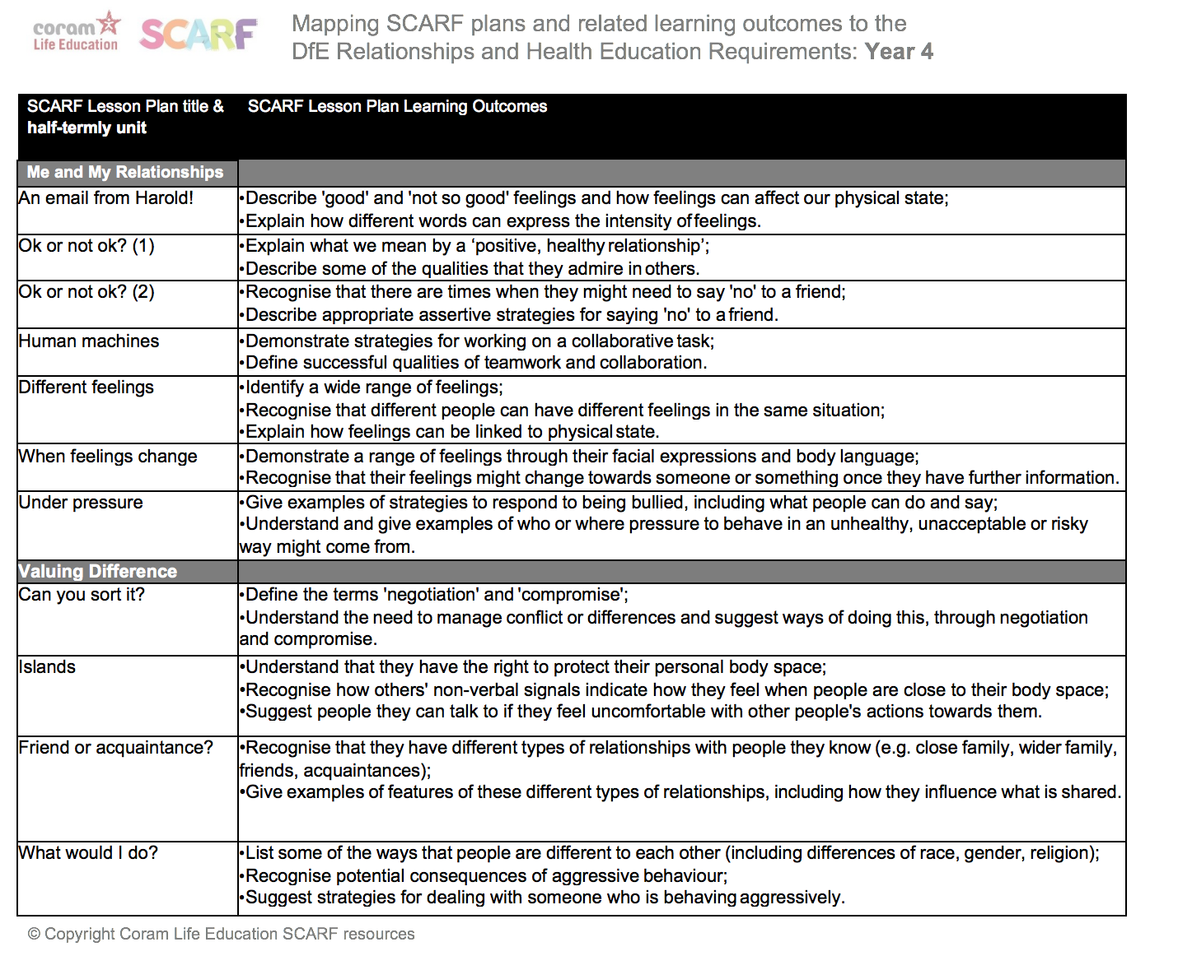
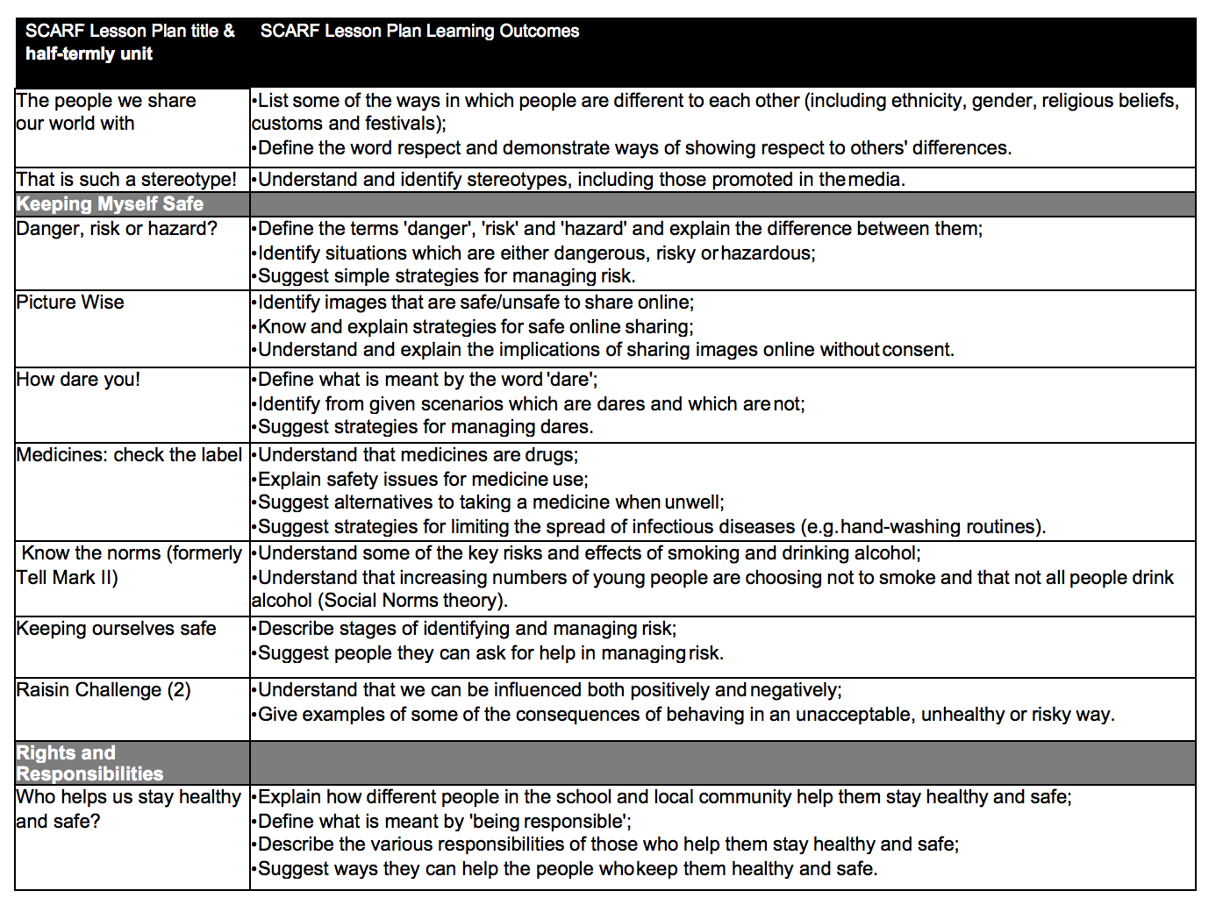
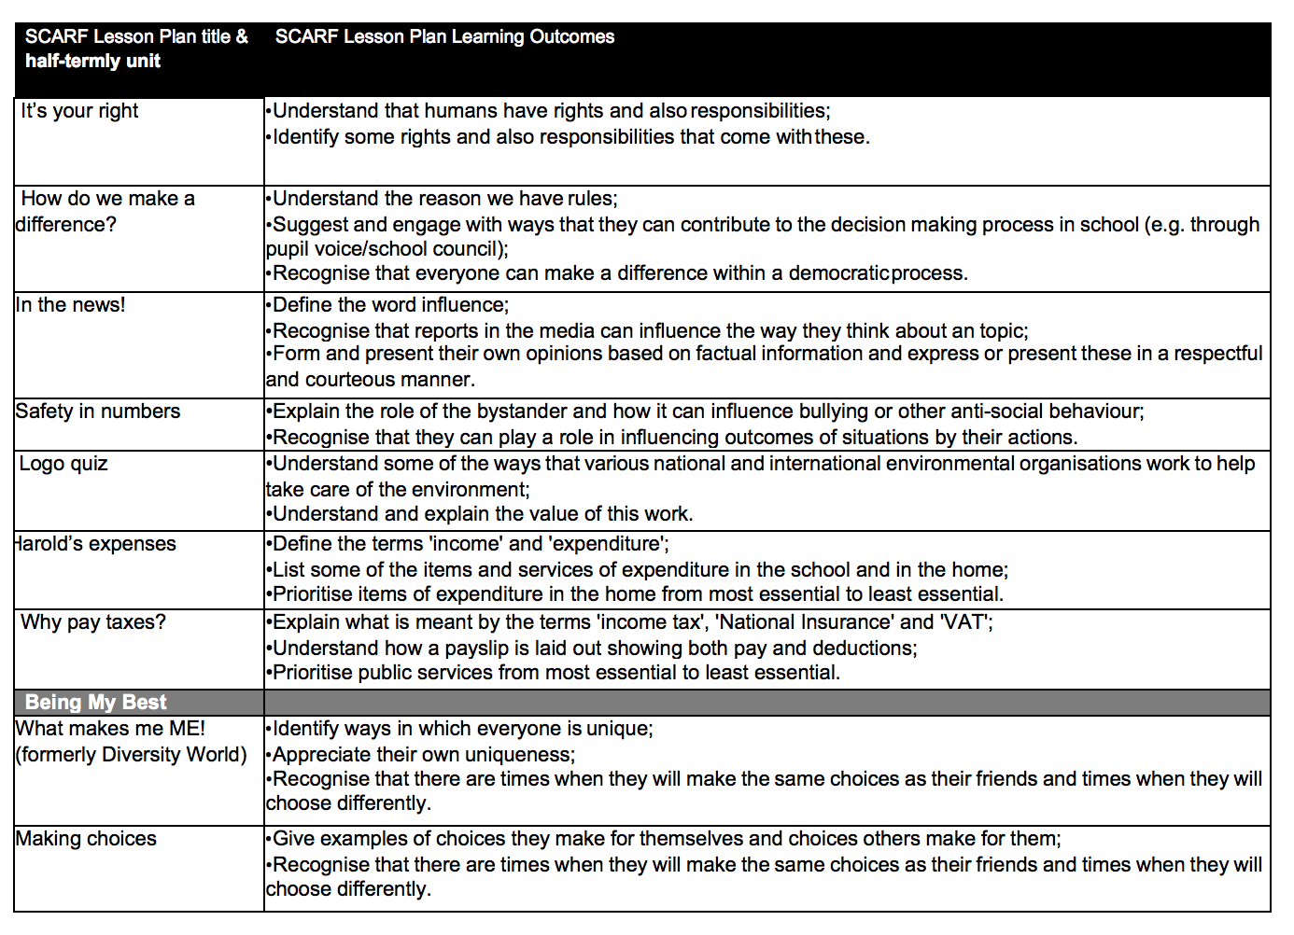
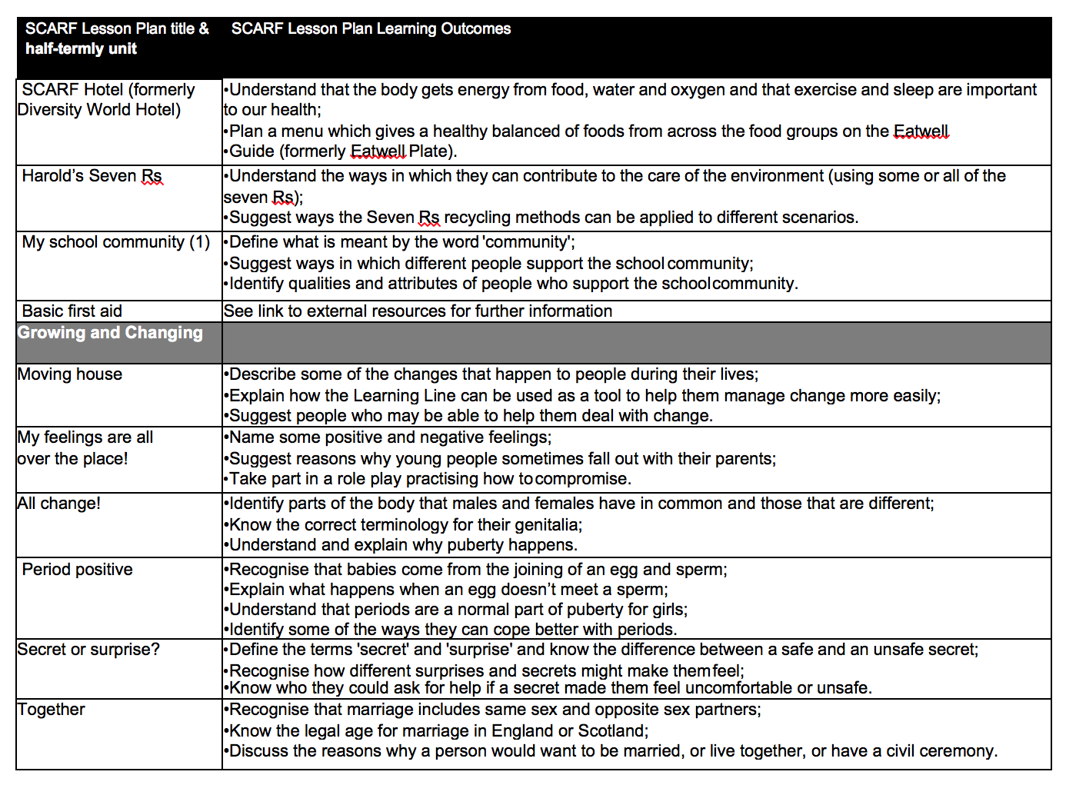
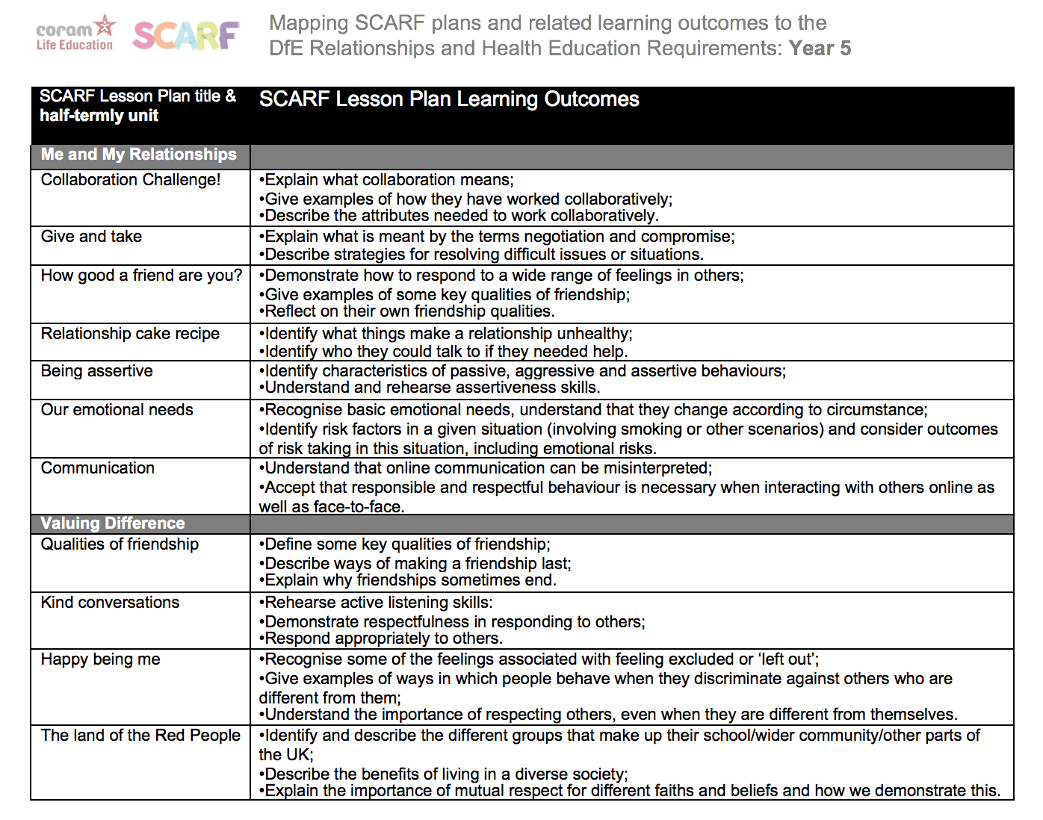

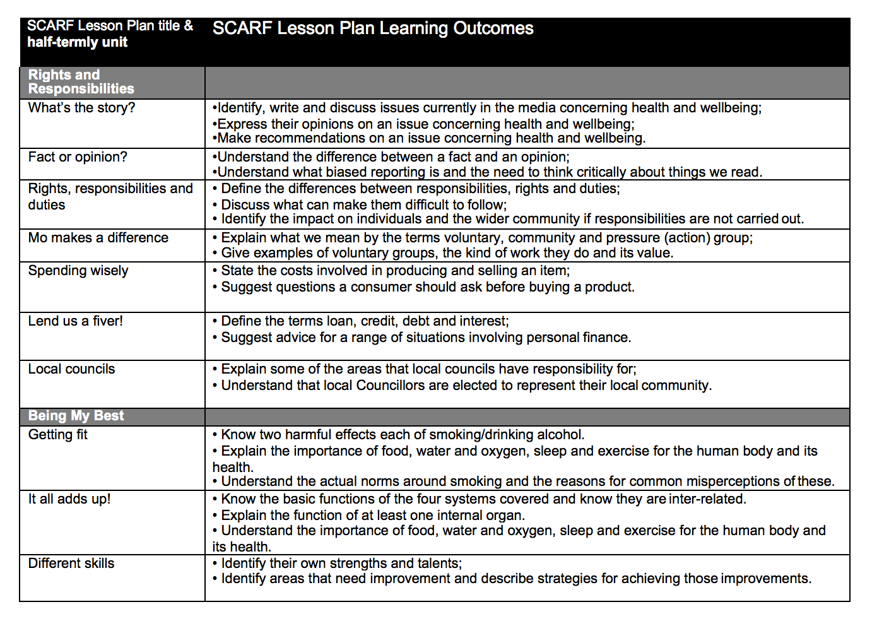
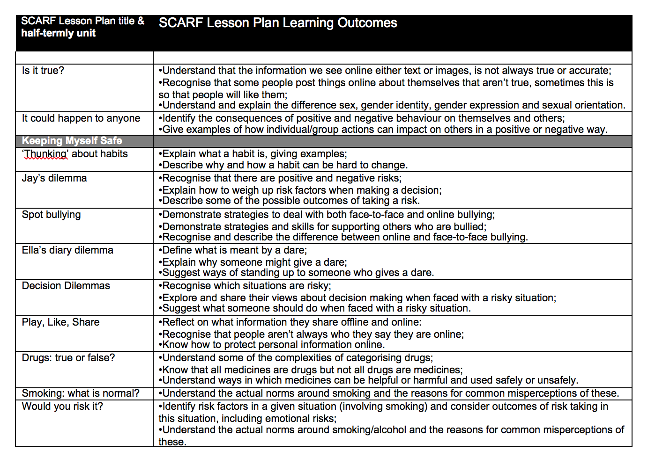
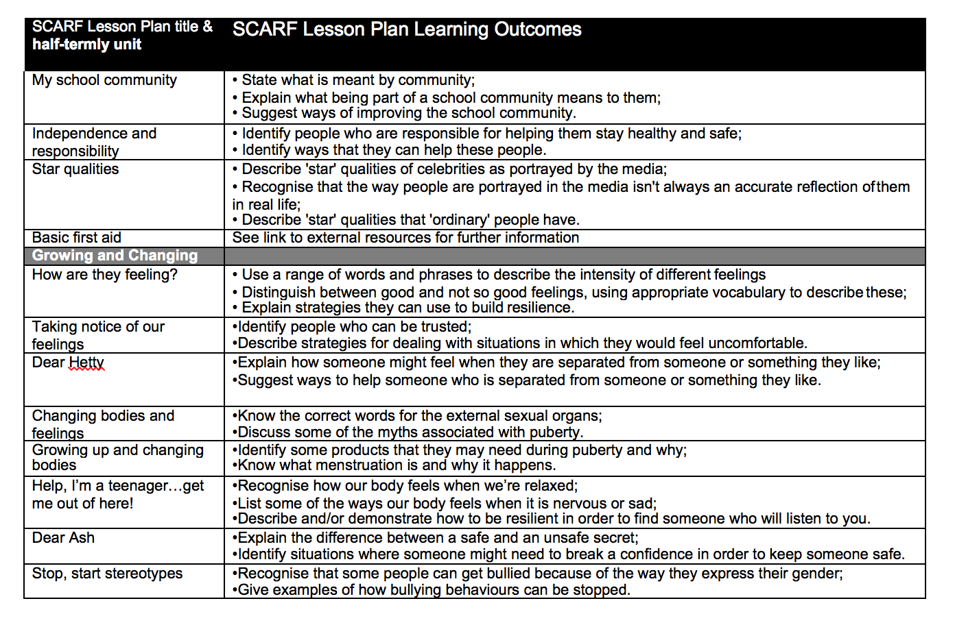
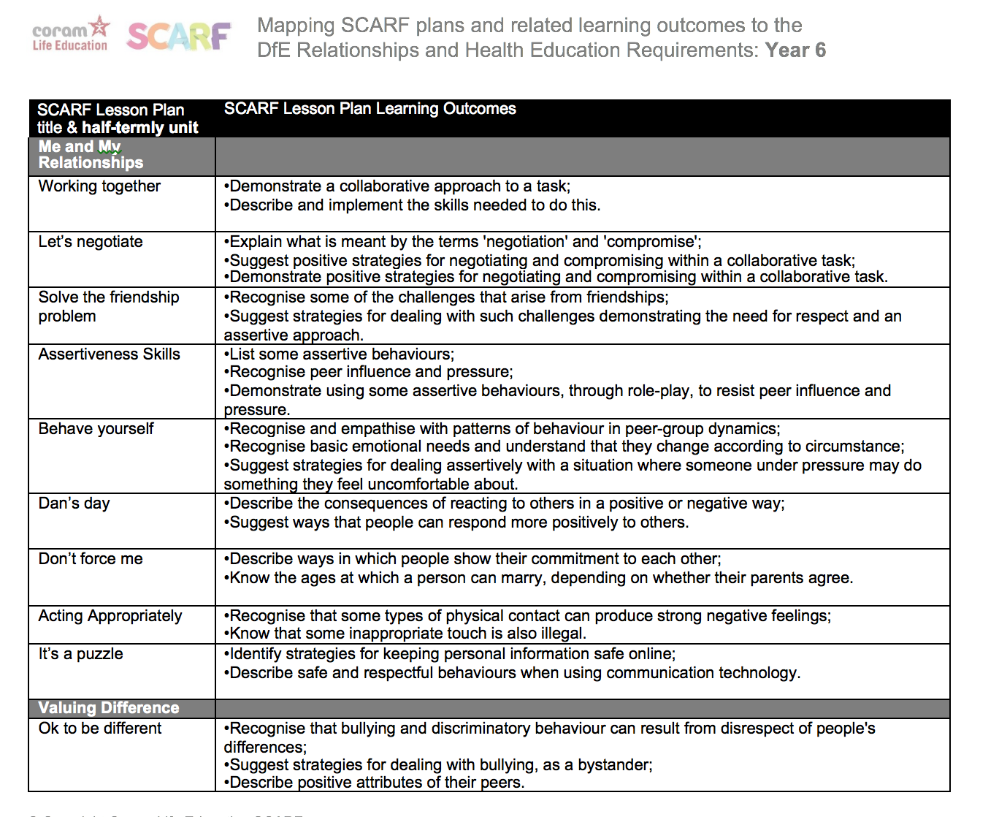
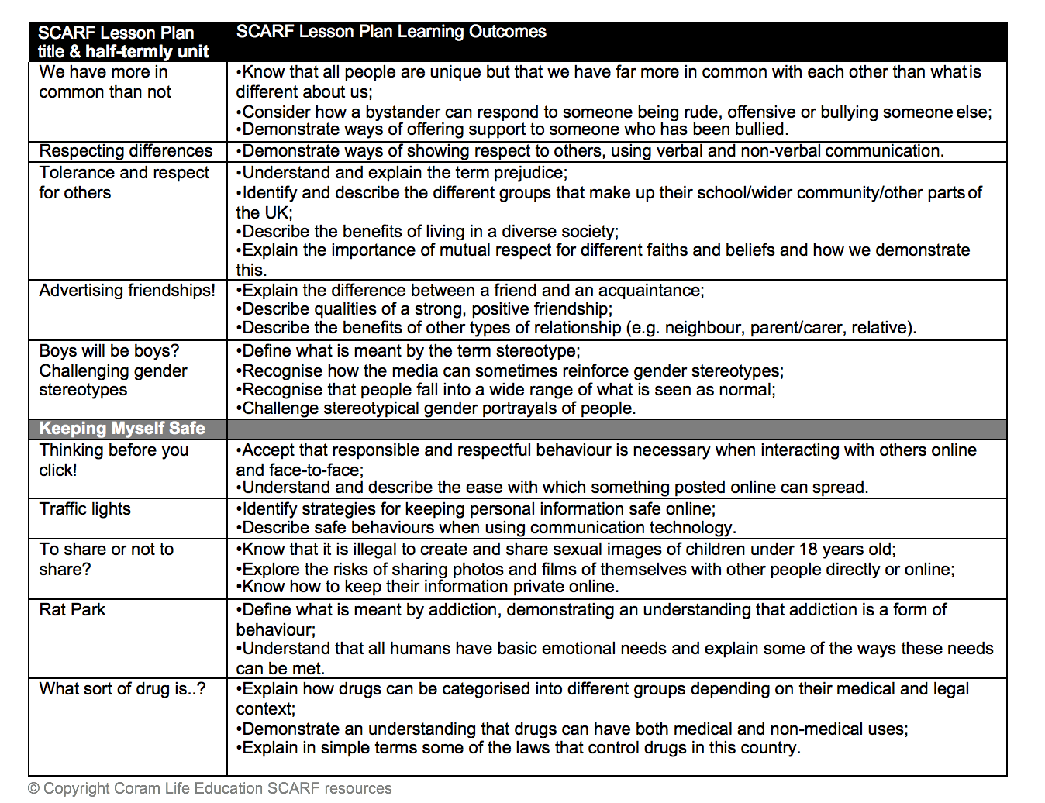
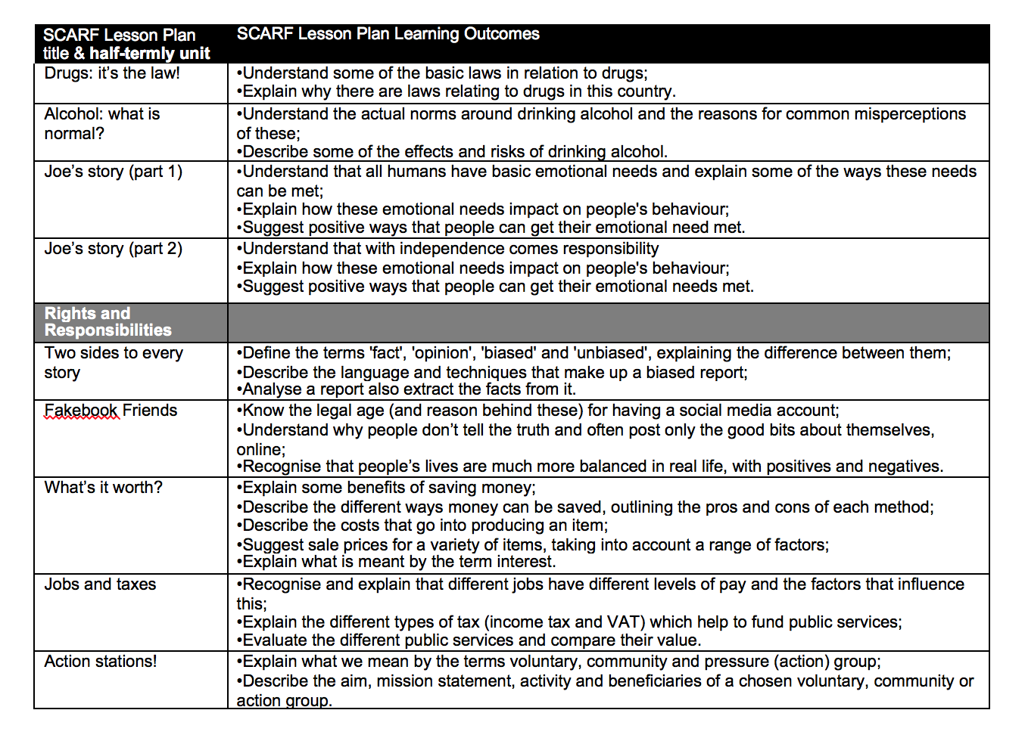
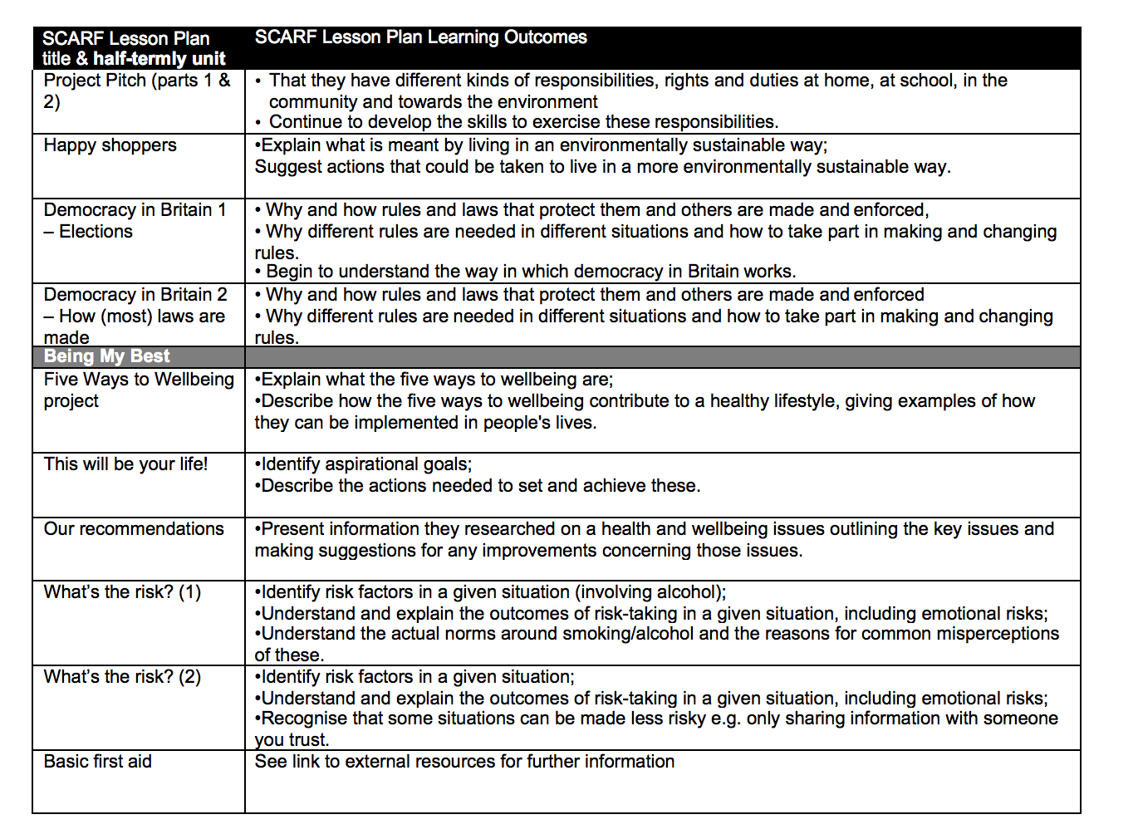

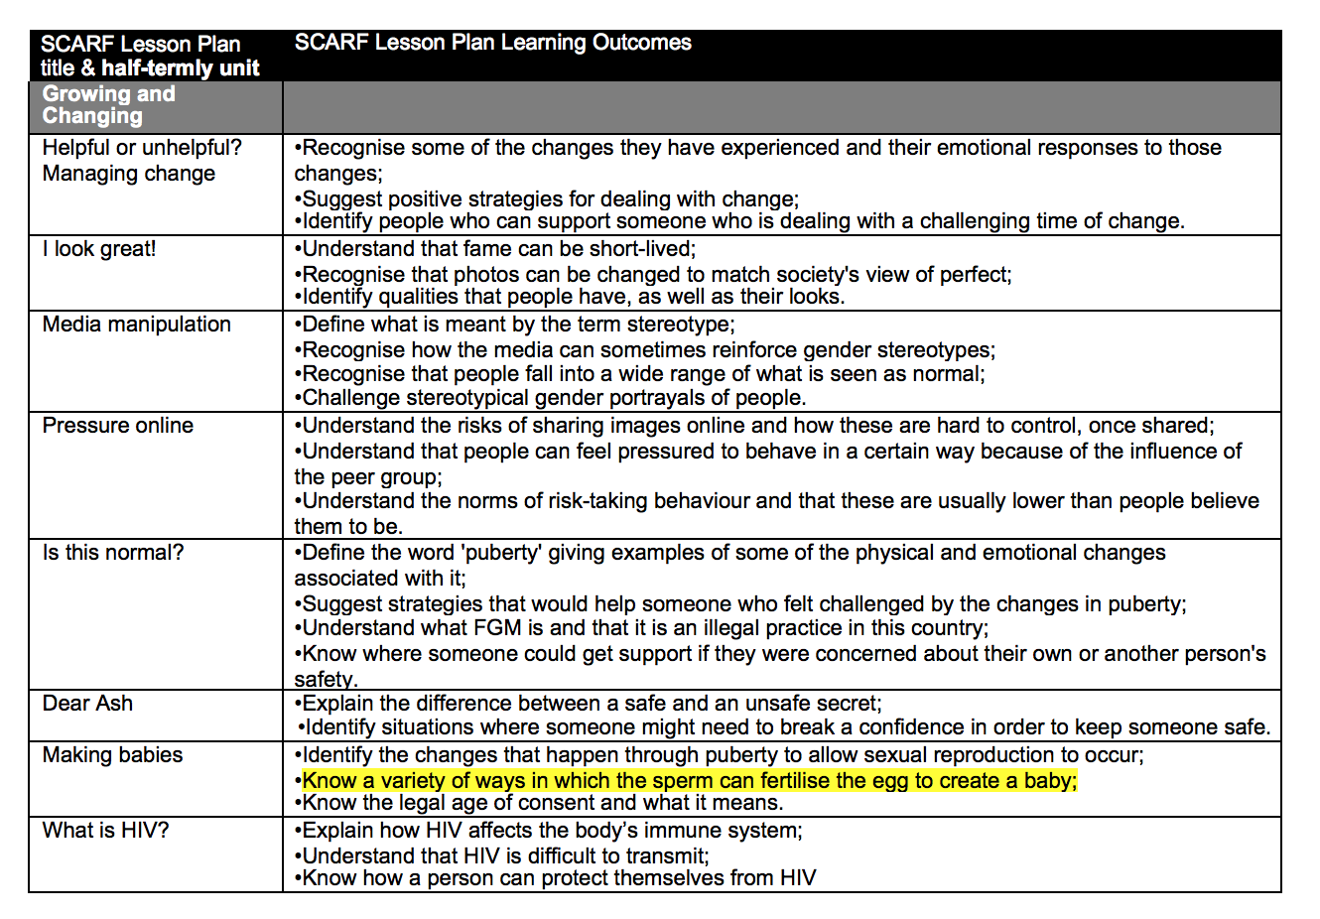
Example teaching resources for each year group.
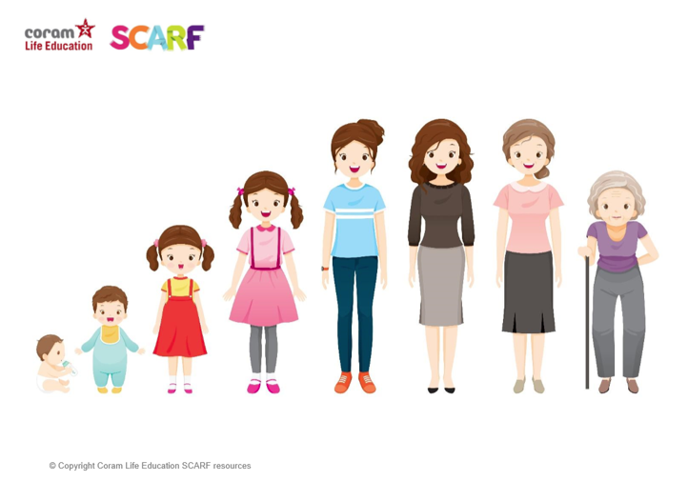
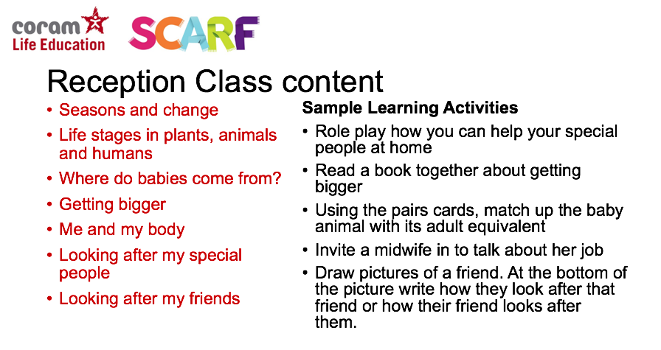
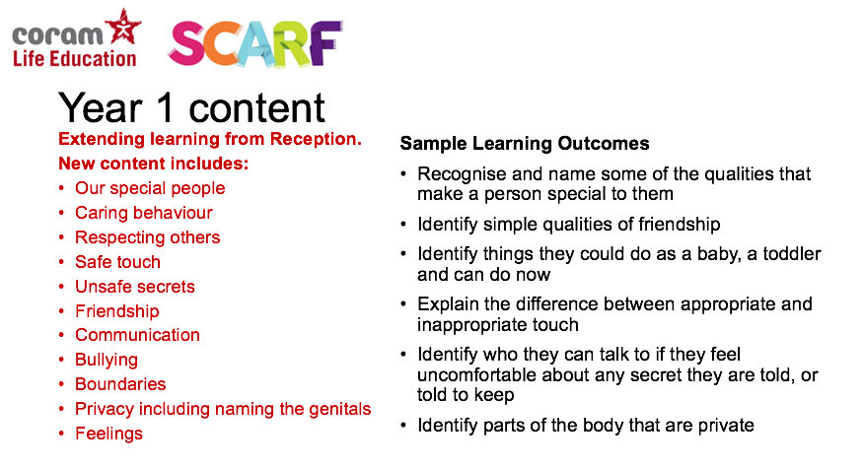
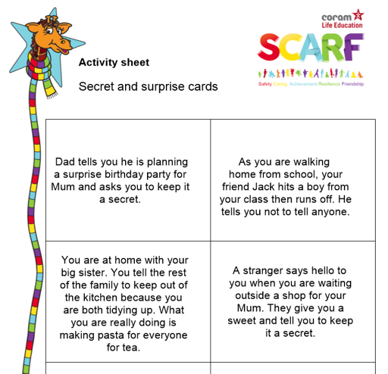

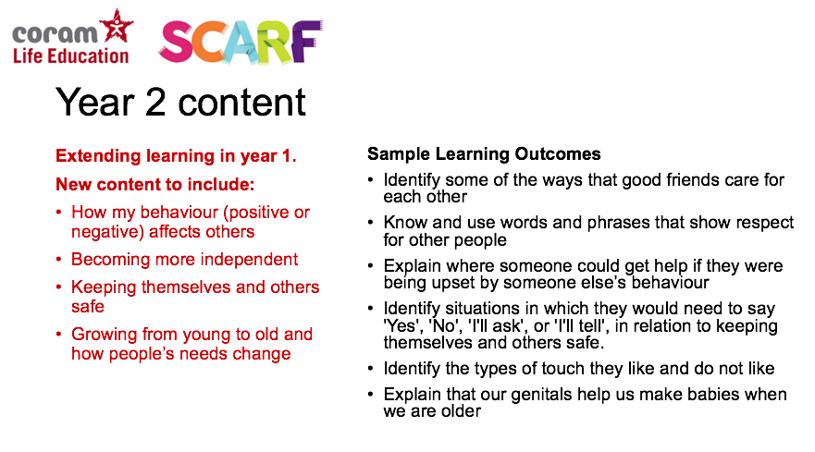
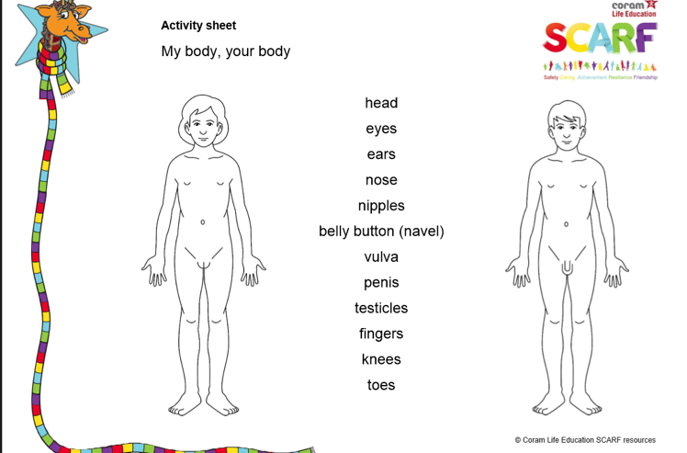
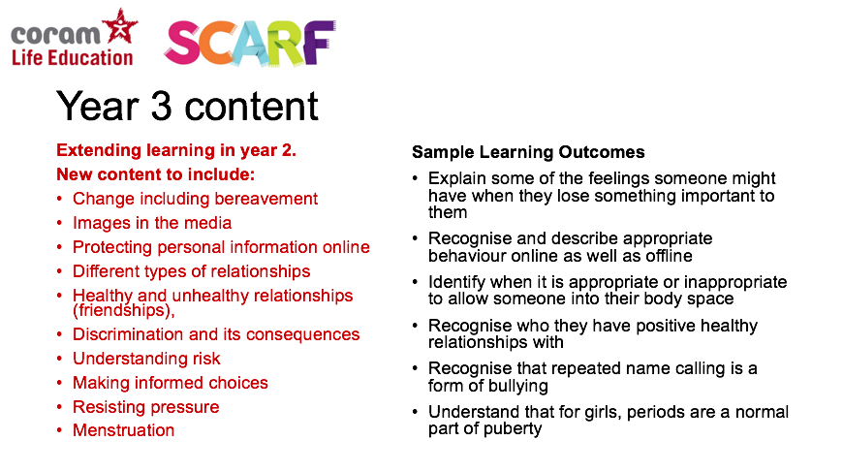
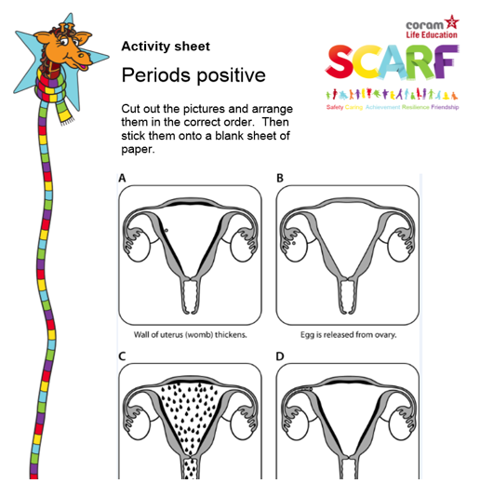
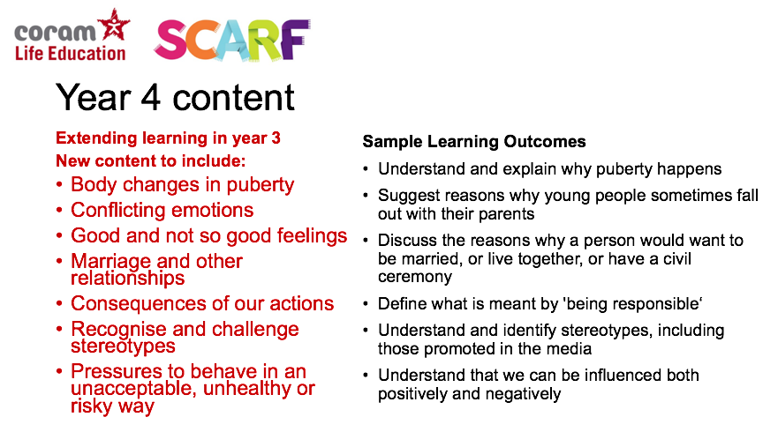
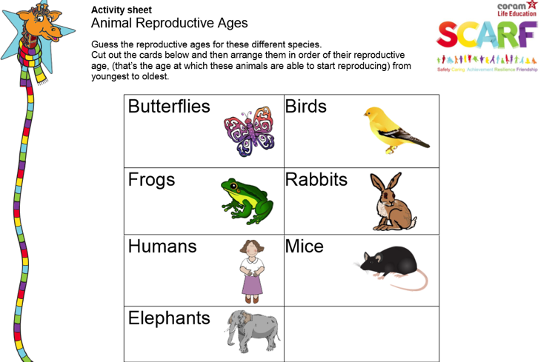
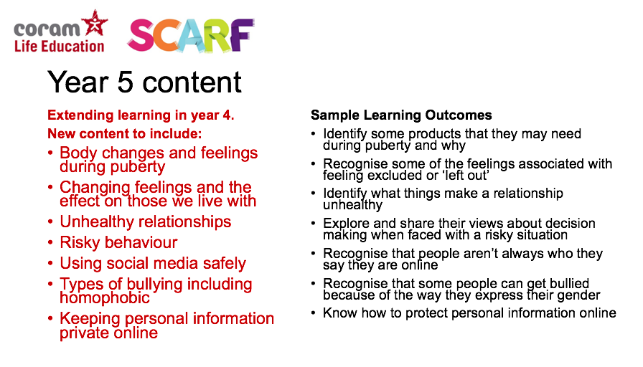
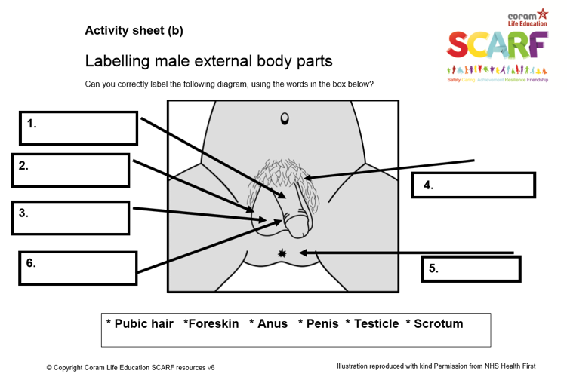
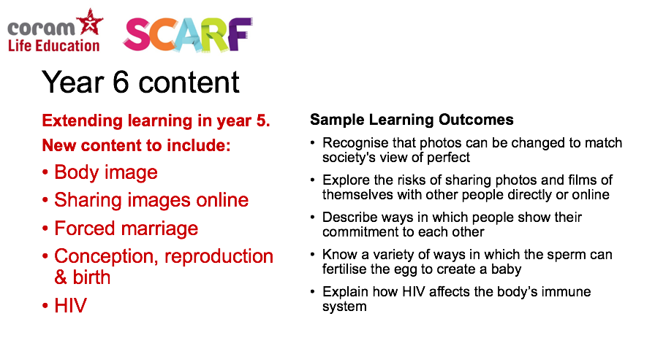
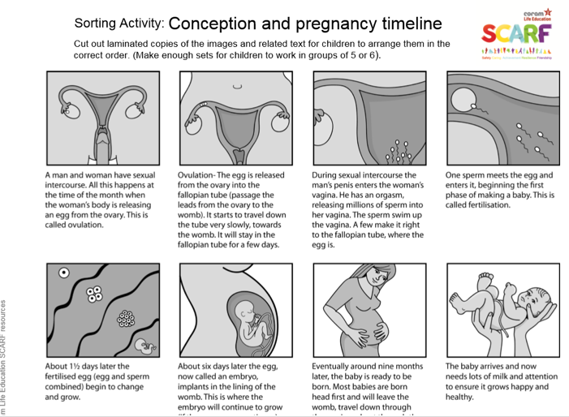
The video shown to children in Year 6 is an animated version of the sheet below. A transcript of what is said in the video can be found on the next page.
Video transcript

Here is the egg leaving the ovary and travelling along the fallopian tube very slowly. Here is a penis entering the vagina. This is known as sexual intercourse. During sexual intercourse, the man releases millions of sperm, about 300,000,000 into the vagina. Their job is to swim to the egg where one of them will enter the egg and fertilise it. Twins occur when two eggs are released at once. Two sperm meet an egg each. Occasionally, the fertilised egg splits into two creating identical twins. About six days later, the fertilised egg, now known as an embryo, travels down the fallopian tube and implants itself into the lining of the womb. This is where the embryo will continue to grow if the pregnancy continues. Eventually, about nine months later, a baby is ready to be born. Most babies are born head first and will leave the womb, travel through the cervix and down through the vagina. This is called labour. If this is not possible, maybe because the baby is in the wrong position, a caesarean will be carried out, where a cut is made to the woman’s tummy and womb and the baby will be taken out this way.

